IUT WORLD CONFERENCE 2019

Conference documents

Vienna
3rd4th October 2019

Contents

List of Members 4
Programme 7
Agenda 10
Appendix 1 - Election of Conference Chair, vice Chair and Conference Secretary 11
Appendix 2 - Roll call 12
Appendix 3 - Minutes from Congress 2016 14
Appendix 4 - Election of IUT President and seat of IUT Secretariat 17
Appendix 5 - Conference statement 22
Appendix 6 - Report of the activities of the International Union of Tenants 2016-2019 25
Appendix 7 - IUT EU Liaison Office Brussels report of activities 2016-2019 31
Appendix 8a - Financial Report / Director’s Report 2016-2018 44
Appendix 8b - Income Statement 45
Appendix 8c - Balance sheet 46
Appendix 8d - Note 1 – Operating profit by cost centre 47
Appendix 8e - Note 2 – Retained profit 48
Appendix 9 - Auditor's report 49
Appendix 10 - Appointment of auditors for 2020 – 2022 53
Appendix 11 - Approval of membership applications 2016-2019 54
Appendix 12 - Cessation of Membership 55
Appendix 13 - IUT Activity plan 2019-2022 56
Appendix 14 - IUT EU liaison office Brussels Activity plan 2019-2022 60
Appendix 15 - International tenants’ day 7th October 2019 66

List of Members

Membership categories
BM: Board Member (minimum annual fee of € 1 500)
M: Member (minimum annual fee of € 60)
AM: Associated Member (no fee)

Africa

Number | Country | Organisation | Category
1 | Benin | Association Solidarité Defense Droits de Locataires, ASDDL | AM
2 | Burundi | Association de Defense des Locataires au Burundi (ADELOB) | AM
3 | Congo-Kinshasa | Association Pour la Protection et Droit des Locataires au Congo (APDLC) | M
4 | Congo-Kinshasa | Association Congolaise d’Assistance aux Locataires (ACALOC) | AM
5 | Ivory Coast | Alliance Ivoirienne pour l’Habitat | AM
6 | Kenya | Kenya Tenants Welfare | AM
7 | Kenya | Union Urban Tenants Association of Kenya | AM
8 | Liberia | Liberia National Associations of Tenants and Residents | AM
9 | Nigeria | National Tenants Union of Nigeria | AM
10 | Nigeria | Socio-Economic Rights Initiative, SERI | AM
11 | South Africa | Organisation of Civic Rights, OCR | M
12 | Tanzania | Tanzania Tenants Association, TTA | AM
13 | Togo | National Consumers and Environment Association of Togo | AM
14 | Uganda | Uganda National Tenants Union, UNTU | AM

Asia

15 | India | Indian Federation of Tenants Council | AM
16 | Japan | Japanese Tenants Association, JTA – 日本借地借家人連合 | M
17 | Nepal | Nepal Tenant Union | AM

Australia & Oceania

18 | ACT, Canberra | Tenants´ Union, ACT, Canberra | M
19 | New South Wales | Tenants Union of NSW Ltd, Sydney | AM
20 | New Zealand | Tenants Protection Association Inc. | AM
21 | New Zealand | Manawatu Tenants Union | AM
22 | Queensland | Tenant's Union of Queensland Inc, TUQ | M
23 | Tasmania | Tenants Union of Tasmania | M
24 | Western Australia | Tenants Advice Service, TAS | AM
25 | Victoria | Tenants Union of Victoria, TUV | AM

Europe

26 | Austria | Mietervereinigung Österreichs, MVÖ | BM
27 | Austria | Österreichischer Mieter-, Siedler- und Wohnungseigentümerbun, ÖMB | M
28 | Belgium | Vlaams Huurdersplatform | M
29 | Belgium | Rassemblement Bruxellois pour le Droit à l'Habitat/Brusselse Bond voor het Recht op Wonen | M
30 | Belgium | Syndicat des Locataires – Huurdersbond | AM
31 | Croatia | Udruga Stanara Hrvatske, Assoc. of Croatian Tenants | M
32 | Czech Republic | Sdružení Nájemníku ČR, SON | BM
33 | Denmark | Lejernes Landsorganisation, LLO | BM
34 | England | Tenants Participation Advisory Service, TPAS | M
35 | England | Tenants and Residents Organisation of England, TAROE | AM
36 | England | National Fed. of Tenant Management Organisations Ltd, NFTMO | AM
37 | England | Generation Rent | AM
38 | Estonia | Eesti Űűrnike Űhingute Liit, Estonian Union of Tenants | AM
39 | Finland | Vuokralaisten Keskusliitto, Central Union of Tenants | BM
40 | France | Confédération Nationale du Logement, CNL | BM
41 | Germany | Deutscher Mieterbund e. V., DMB | BM
42 | Israel | Organisation for the Protection of Tenant’s Rights | AM
43 | Italy | Unione Nazionale Inquilini Ambiente e Territorio, UNIAT | M
44 | Italy | Sindicato Inquilini Casa e Territoria, SICET | M
45 | Italy | Sindicato Unitario Nazionale Inquilini ed Assegnatari, SUNIA | AM
46 | Latvia | Latvia Tenant Association | M
47 | North Macedonia | Union for Protection of Tenants, ”MakeDom” | AM
48 | Northern Ireland | Supporting Communities | M
49 | Norway | Leieboerforeningen, Norwegian Tenants Association | BM
50 | Poland | Polskie Zrzeszenie Lokatorów, PZL | M
51 | Portugal | Associacao dos Inquillinos Lisbonenses, AIL | M
52 | Romania | Liga Asociatiilor de Propriatari Habitat, HABITAT League of Homeowners Associations | M
53 | Russia | Russian Tenants Association – Ассоциация нанимателей жилья «РАНЖ» | M
54 | Scotland | TPAS Scotland | M
55 | Scotland | Tenants Information Service, TIS | M
56 | Scotland | Living Rent | AM
57 | Slovakia | Občianske združenie Právo na bývanie (Right to Housing) | M
58 | Slovenia | Združenje Najemnikov Slovenije, Assoc. of Tenants of Slovenia | AM
59 | Spain | Federació d´Associaciones de Veїns d´Habitage Social de Catalunya, FAVIBC Catalonia, Barcelona | M
60 | Sweden | Hyresgästföreningen, Swedish Union of Tenants SUT | BM
61 | Switzerland | Schweizerischer Mieterinnen-und Mieterverband/Deutschschweiz | BM
62 | Switzerland | Association Suisse des Locataires, ASLOCA Romande | BM
63 | Switzerland | Associazione Svizzera Inquilini | AM
64 | the Netherlands | Nederlandse Woonbond | BM
65 | Wales | Welsh Tenant's Federation Ltd | M
66 | Wales | TPAS Cymru | M

North America

67 | Canada | Tenants´ Resource & Advisory Centre, TRAC. Vancouver, BA | M
68 | Canada | Federation des Locataires d´habitations à loyer modique du Québec, FLHLMQ | M
69 | Canada | Federation of Metro Tenants' Associations, FMTA, ON | AM
70 | USA | San Francisco Tenants Union, STU | AM
71 | USA | NAHT, National Alliance of HUD Tenants | AM

Programme

Thursday 3rd October 2019

9.30 a.m. Registration and coffee

10.00 IUT AGM and Members meeting
Opening speech: Georg Niedermühlbichler, President of the MVÖ
Speech: Kathrin Gaal, Executive City Councillor for Housing
Speech: Marie Linder, Newly elected President of the IUT
IUT Members meeting - see separate agenda

12.30 Lunch

13:30 Open Session - The Vienna Housing Market
13.50-14.10 Daniel Glaser, Representative of the MA 50
The Vienna model for affordable housing
14.10-14.30 Christian Bartok, Representative of the Mieterhilfe
How the City of Vienna supports its tenants via its free service Mieterhilfe (Tenancyhelp) www.mieterhilfe.at/

The EU
14.30-14.45 European Citizens ‘Initiative Housing for All
Presented by the initiative’s spokeswoman Karin Zauner-Lohmeyer

14.45-15.15 Coffee break

International sessions
15.15 to 15.45 International panel on the financialisation of housing
Push the film trailer as introduction
Moderated by Erik Elmgren, Chief negotiator & Head of Housing Department, Swedish Union of Tenants

15.45 to 16.30 International roundtable sessions and exchange of knowledge

Keynote speech
16.30 The UN sustainable development goals
Recorded message by Claudio Acioly Jr. Head UN Capacity Development Unit, Senior Housing & Urban Management Expert UN-HABITAT - United Nations Human Settlements Programme
Speech by Ellen Geurts, on the Sustainable Development Goals and the new Urban Agenda. Ellen is a Dutch housing expert whose career span from more than 15 years in the international arena as an expert associated with the Rotterdam-based Institute for Housing and Urban Development Studies-IHS.

17.00 Photo session

19.00 Conference dinner
Location: Badeschiff, Obere Donaustraße 97-99/3/3,
Hosted by the International Union of Tenants

Friday 4th October 2019

9.00 Registration and coffee

9.30 International Round-table sessions
Each subject will be introduced by the speaker to all participants for 10 minutes followed by roundtable discussions for 45-60 minutes to exchange ideas and best practice. Participants are asked to join the roundtable of their choice for international exchange discussions.

9.30 1. Strategies against skyrocketing rents - Rent control systems vs. market
rents
Introduced by Reiner Wild, and Wibke Werner, Directors of Berliner Mieterverein who will present the Berlin Government’s initiative of rent caps.

9.40 2. The importance of organisation of tenants
Eddie Jacquemart, President of CNL

10.00-11.00 Roundtable sessions on the above subjects

11.00-11.30 Coffee break

11.30 3. Short term rental platforms
Introduced by Martin Hofverberg, Chief Economist, Swedish Union of Tenants followed by a discussion including strategies against “touristification”.

11.40 4. Political campaigning by Tenants’ Unions
Experience from Sweden and the campaign against market rents ahead of the Swedish general election introduced by Dan Nicander, Head of South Regional Office, Malmö, Swedish Union of Tenants, followed by an exchange of best practice and ideas around campaigning.

11.50 5. Social agreement of the Woonbond and landlords
case study presentation by Paulus Jansen, Director of the Woonbond (The Tenants Union of the Netherlands) followed by a discussion on rent negotiation models between tenants and landlords around the world, amongst participants.

12.00-13.00 Roundtable sessions on the above subjects

13.30 Study Visits (lunch to-go)

Study Visit A
Old social housing in Vienna
• Municipal housing along the Gürtel
• Karl-Marx-Hof
• Exhibition “Das rote Wien”
Study Visit B
New social housing in Vienna
• Sonnwendviertel

17.00 End of Conference

Agenda

IUT World Conference
Members meeting, Vienna 3 October 2019
Venue: City Hall, Vienna

Appendix
- Opening of the meeting
- Adoption of the Agenda
- Election of 1
  - chair of the conference
  - secretary
- Roll call 2
- Minutes from Conference 2016 3
- Announcement of Elections of 4
  - IUT President and Vice Presidents 2019-2022
  - Headquarter of IUT Secretariat for 2019-2022
- IUT Conference statement 5
- IUT activity reports, summary 6 and 7
- Financial reporting
  - Financial Report 2019-2022 8 a-e
  - Auditor’s report 9
- Appointment of Auditors 2017-2019 10
- Motions
- Report on new members 2016-2019 11
- Report on cessation of membership 2016-2019 12
- IUT Plan of action, goal and intentions 13 and 14
- International tenants’ day 2019 15
- Other business
- Next Conference 2022
- Closing of Members’ meeting
Followed by Member conversations/roundtables

Appendix 1

Election of Conference Chair, vice Chair and Conference Secretary

The Executive Committee proposes the World Conference to elect;

as Chair of the Conference: Ilene Campbell
as Secretary: Stefan Runfeldt, IUT

Appendix 2

Roll call

Delegations to the 21st Wold Conference

Country | Organisation | Head of delegation | Role
Australia | Tenants Queensland | Penny Carr | M
Austria | Mietervereinigung Österreichs | Georg Niedermichbueller | BM
Belgium | Vlaams Huurdersplatform | Geert Inslegers | M
Canada | Fédération des locataires d’habitations à loyer modique du Québec (FLHLMQ) | Elisabeth Pham | M
Czech Republic | Association of Tenants of the Czech Republic (SON) | Milan Taraba | BM
Denmark | Lejernes Landsorganisation | Helene Toxvaerd | BM
England | National Federation of Tenant Management Organisations | Lucia Otto | M
Finland | Vuokralaiset VKL ry | Anne Viita | BM
France | Confederation Nationale du Logement - CNL | Eddie Jacquemart | BM
Germany | Deutscher Mieterbund e.V. (DMB) | Rolf Gaßmann | BM
Italy | Sindacato Inquilini Casa e Territorio | Fabrizio Esposito | M
Italy | Sindacato Unitario Nazionale Inquilini e Assegnatari | Alessandra Gava | M
Latvia | Latvijas Irnieku Apvieniba (LĪA) /  Latvia Tenants Association | Edvards Kvasnevskis | M
Nepal | Federation of Tenants Unions Nepal | Shankar Koirala Kshetri | AM
The Netherlands | Nederlandse Woonbond /  Dutch Union of Tenants | Paulus Jansen | BM
Nigeria | National Union of Tenants of Nigeria | Emmanuel O.Eyetan | AM
Northern Ireland | Supporting Communities N.I. | Colm McDaid | M
Poland | Polskie Zrzeszenie Lokatorów /  Polish Association of Tenants | Marta Kotnowska | M
Portugal | Associacao de Inquilinos Lisbonenses | Prof.Luis Mendes | M
Romania | Liga Asociatiilor de Propriatari Habitat /  Habitat League of Romania | Dorina Lupse | M
Russia | Russian Tenant Union / National Research University, Higher school of economics | Prof. Elena Shomina | M
Scotland | Tenants Information Service (TIS) | Ilene Campbell | M
Scotland | TPAS Scotland | Lesley Baird | M
Slovakia | The Slovak Association of Tenants | Tadeus Patlevič | M
Sweden | The Swedish Union of Tenants | Marie Linder | BM
Switzerland | Mieterinnen- und Mieterverband Schweiz, ASLOCA | Natalie Imboden | BM

Observers

Country | Organisation | Role | Name
Austria | Brussels Liaison Office of the City of Vienna | Director | Michaela Kauer
Denmark | Danske Lejerne |  | Jorgen Dyrholm Jensen
Germany | Institut für Soziologie, Technische Universität Berlin | Doctor | Johanna Hoerning
Germany | Rechtsanwalt | Lawyer/Consultant | Sebastian Richter
Germany | Kabelnet.de | Journalist | Martin Zähringer
Germany | Freelance | Journalist | Jane Tversted
IUT | International Union of Tenants | Intern | Ilaria D'Áuria
Nigeria | Government of Rivers State, Federal Republic of Nigeria | Secretary to State Government | Dr T.W.Danagogo

Appendix 3

Minutes from Congress 2016

Minutes
20th IUT World Congress, Glasgow
October 14-16, 2015

1. a. Opening of the meeting  b. Tribute to Anna Pachtová  c. Other businesses | - President Sven Bergenstråhle welcomed everyone to Glasgow and opened the meeting. He thanked the TPAS Scotland for their hospitality to host the IUT Congress meeting.  - The Congress paid tribute to Anna Pachtová 1951-2016, who was a long-standing member of the IUT Board.  - One issue was added, regarding the IUT Statues.
2. Adoption of the agenda | The agenda was adopted without changes.
3. Election of  a. Chair and Vice Chair  b. Secretary | - Jennie Osbourne of the TPAS England was elected Chair.  Anna Lönn Lundbäck of the Swedish Union of Tenants was elected Vice Chair.  - Stefan Runfeldt of the IUT Secretariat was elected secretary.
4. Roll call | The Chair called the heads of the delegations.  For a complete and up-dated list, please see Appendix I.
5. Minutes from previous Congress 2013, Krakow | The minutes from previous Congress 2013, Krakow was adopted without revisions.
6. Elections of  a. IUT President 2017-2019  b. Headquarter of IUT Secretariat for 2017-2019 | - Sven Bergenstråhle was re-elected as President of the IUT for the next Congress period 2017-2019.  - The Swedish Union of Tenants has offered to continue hosting the IUT Headquarter for the next Congress period 2017-2019, the offer was kindly accepted by the Congress.
7. IUT Congress Statement | The Congress statement was reviewed and agreed, then adopted. Heads of delegations then signed the Statement. The statement was made available immediately on social media channels. For full statement, see Appendix II.
8. IUT activity report 2013-2015 | Magnus Hammar, Secretary General, and Barbara Steenbergen, Head of IUT liaison office in Brussels, presented the IUT activity report for 2013-2015.  IUT has today (August 2016) 68 national or regional members, in 44 countries – six more than in 2013. One member, BIHUSS, Bosnia & Hercegovina, has shut down their office and activities. New members are from; England, Northern Ireland, Belgium, Scotland and Nepal.  IUTs´ liaison office to the EU in Brussels has been very active, lobbying major EU institutions; EU parliament, Committee of the Regions and European Economic and Social Committee, and have been participating in a large number of conferences and networking events.  IUT project funding has been made available, in 2013, for IUT member in Poland  The full activity report was available as a separate document among the congress documents  The Congress adopted the report. For full report, see Appendix III.
9. Financial Reports  a. Financial Report 2013-2015  b. Auditor’s report  c. Discharge from liability  d. Triannual IUT budget | Magnus Hammar presented the financial report and the auditors´ report for the fiscal years 2013-2015.  The Congress adopted the reports, with one remark and some suggestions stated below, and decided to discharge the secretariat from liability.  Remark: The IUT need more members and more board members, also look into the membership fees. The Secretariat will look into these issues and come back to the Board for suggested changes.  Correction item 9d, IUT triannual budget: Item 21 (congress 2019) should be -30 000 € (not -15 000 €). And 3x10 000 € (for 2016, 2017, 2018).  Total costs 2016-2018: -294 500 €. TOTAL for 2016-2018: -14 100 €
10. Appointment of Auditors | The Congress approved the suggestion from the Board to accept Ernst & Young Ltd, or other auditor chosen by the Swedish Union of Tenants, and two representatives of the Swedish Union of Tenants as auditors for 2017-2018.
11. Motions | No motions had been submitted to the IUT Secretariat within the stipulated time, of two months before congress.
12. Approval of membership applications 2013-2015 | Approval of membership applications 2013-2015 (2016) of the following organisations:  Categories: M=Member (paying €60,00/year), AM = Associated Member (no fee)  a. Supporting Communities NI, Northern Ireland, as category M Accepted by IUT board May 9, 2015.  b. Living Rent, Scotland as category AM Accepted by IUT board May 21, 2016 c. Tenants Information Service, TIS, Scotland, as category M Accepted by IUT board May 9, 2015.  c. Tenants Information Service, TIS, as category B. Accepted by IUT board May 21, 2016.  d. Nepal Tenant Union, as category AM Accepted by IUT board May 21, 2016.  e. Vlaams Huurdersplatform, Belgium, as category M Accepted by IUT board on April 25, 2014.  f. Generation Rent, (Previously, National Private Tenants Organisation), England, as category AM. Accepted by IUT board April 19, 2013.
13. Report; Ceasing of membership 2013-2015 | Bosnia & Hercegovina: Udruženje stanara “Bihuss” Sarajevo, due to the closure of the organisation.
14. IUT Plan of action, goal and intentions | Main goals and intentions 2017 – 2019 include actions on the following areas:  - Housing rights, and secure tenure  - Affordable rental housing  - Pros for rental housing  - Social housing  - Energy and energy costs  - Tenure neutrality  On the EU Issues the focus includes:  - Housing and state aid, Energy policy  - EU stability pact, European Semester and Country Specific  Recommendations  - European Pillar of social rights  - EU funding for housing  - EU Parliament elections 2019  - European Responsible Housing Initiative  - Internal Affairs  - Partnerships  For full report, see Appendix IV.
15. Other issues, points of information | The IUT Statues  The IUT President presented a proposal from the board to form a group to review the statues of the IUT and put forward a proposal to send out to all members in the beginning of next year, give the members two months to give their opinions. The work group will then make a revised proposal, and send it out again at least one month to all members before the board makes its decision. The Congress approved the proposal from the board.
16. Next congress, 2019 | The Secretary general invited the organisations to come forward to the board with suggestions for where to hold the next IUT Congress.
16. Closure of Congress | President Sven Bergenstråhle thanked all board members and closed the meeting.

Appendix 4

Election of IUT President and seat of IUT Secretariat

The IUT Board has elected Marie Linder as IUT President for the period from the Board Meeting ahead of the World Conference in 2019 to the World Conference 2022. See following page for Marie Linder’s CV.

The IUT Board has elected Jan Laurier and Rolf Gaßmann as Vice Presidents for the period from the Board Meeting ahead of the World Conference in 2019 to the World Conference 2022. See following pages for their respective CVs.

The Swedish Union of Tenants has offered to continue to host the IUT Head Office of IUT for the period 2019 to 2022.

CV  Marie Linder  Personal information:  Born 30th of April 1963  Living in Tyresö, Sweden  Married, two daughters (*1989 and *1992) | 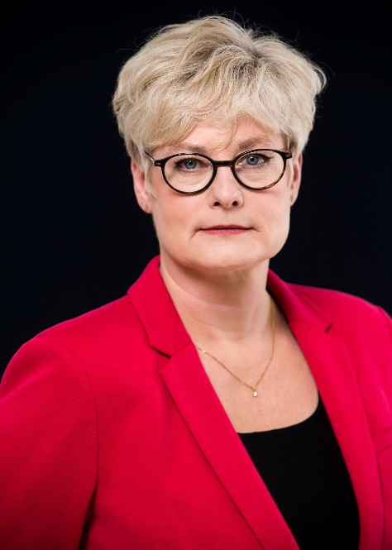

Education:
1987 Studies in journalism – Poppius Journalistskola
1995-1998 Studies in Economic history, Political science and Swedish language at
The Stockholm University
1997 Studies in Literature at The Uppsala University

Professional experience:
1999 - 2003 Deputy Opposition Leader, Municipality of Tyresö, Stockholm
Represent the opposition in different contexts and to receive, forward and anchor information to all opposition parties.
2004 - 2014 Head of Communications, The Swedish Trade Union Confederation
(LO, Landsorganisationen i Sverige)
In charge of long-term communication and strategic policymaking, the regional organisation and the union senior leadership training
2014 - President, Hyresgästföreningen (The Swedish Union of Tenants)
2019 - President, Sveriges Konsumenter (The Swedish Consumers' Association)

Leadership programs:
Political: municipal leadership, state secretary training
Trade union: negotiation training, management education
Non-profit sector: strategic leadership for non-profit organizations

Board of Directors assignments:
President Swedish Folk High Schools
Board member Bilda förlag, publishing house
Board member University of Jönköping
Board member Fonus Funeral Service
Board member Hem & Hyra, Hyresgästföreningen member magazine

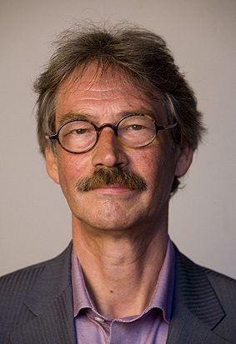
CV

Jan Laurier

full name: Johannes Pieter Laurier
date of birth: 15 November 1949
address: Netherlands, Leiden, 2313 AL Herenstraat 52
family state: married, 3 (steph-)daughters, 1 son, 1 foster daughter (+), 1 foster son nationality: dutch

Education:

1968 successfully ended high school
1973 successfully ended teachers training college
1981 successfully ended study sociology at the Leiden University
2004 qualified advisor and trainer in integrity Neyenrode University

Professional experience:

1972-1973 Military service
1973-1977 Several jobs as a factory worker, teacher on elementary schools, teacher on a training college for civil servants and assistant at the universities of Leiden en Utrecht
1977-1993 Teacher and researcher at the Leiden university
teaching subjects: sociological theory, empirical sociology and sociology of organisations research subjects: spatial development, housing and welfare state questions ending up as coördinator (director) of the universities researching group
1987-2003 Councillor of the city of Leiden
1993-2002 Deputy mayor of the city of Leiden
2003-2011 Independent president of an advisory council of the Dutch government on social security
2004-2016 President of the Dutch Union of Tenants
2006-till now President of the executive board of a foundation which gives hallmarks to organisations on services on labour and sustainable employment (about 600 private companies and (semi)public organisations as cliënt)2011-till now president of the board of the Dutch organisation of shelters for homeless and victims of domestic violence
2012-2013 Chairman of the investigation committee investigating the aftermath care of the mall-shooting incident in Alphen aan den Rijn
2007-2011 member of Dutch Parliament (Senate)
2009-till now President of the board president of the Professional Association of Dutch Social Workers

2013-till now Advisory member of the board of Organisations in the field of Social Work in the Netherlands
2013-till now Vice-president of the IUT

Publications:

(co)editor and writer of several books (6) Writer of several articles and columns

Palmares:

1998 Citizen of honour of the city of Juigalpa (Nicaragua) for social projects in the city
2000 Honorable chief of the Xhosa-people (South-Africa) among other due to a housing project in one of the larger townships in East-London, now Buffalo-city
2012 The Dutch queen honoured me with a knighthood in the order of the house of Oranje-Nassau for my work as a deputy-mayor in the social field in the city Leiden en the Netherlands
2013 De Bronzen Bever (the Bronze Beaver), an award of a Dutch housing corporation for the important work for the position of tenants
2013 De Leidse Broodpenning (the Leiden Bread Penny), an award of the protestant churches of Leiden for those who made difference for the poor people in the city
2016 The Dutch king promoted me to officer in the order of the house of Oranje-Nassau among other for my work at the Dutch Union of Tenants

CV  Rolf Gaßmann  Personal information:  Born 18th of December 1950 in Muehlhausen/Thuringia,  living in Stuttgart since 1953,  two daughters (*1993 and *1998) | 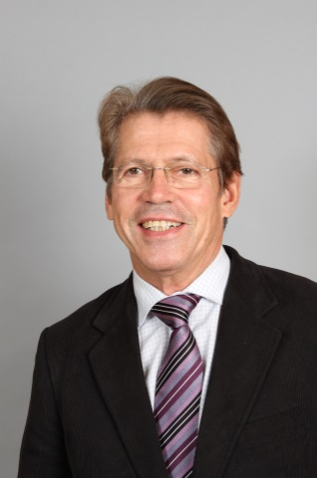

Education, career, professional responsibilities and functions:
After high school graduation initial training as a bank officer in Stuttgart.
Studies in Politics and Economics at the University of Hohenheim, Stuttgart.
From 1978 until 2015 teacher at vocational business schools.
Since 2015 independent consulting activity.

Political Functions:
Member of the municipal council of Stuttgart from 1989 to 1992.
Member of the State Parliament of Baden-Wuerttemberg from 1992 to 1996 (secondary mandate) and from 2001 to 2006 (direct mandate). In this position also spokesman for housing policies in the Social Democratic Party’s (SPD) parliamentary faction.
Since 2016 collaboration with the housing alliance of the state Baden-Wuerttemberg

Functions in the tenant’s organisation
Since 1985 chairman of the Tenants Association Stuttgart (Mieterverein Stuttgart),
2000 to 2004 deputy state chairman of the German Tenants Organisation (Deutscher Mieterbund) for Baden-Wuerttemberg,
since 2004 state chairman of the German Tenants Organisation for Baden-Wuerttemberg,
since 2007 member of the executive committee of the German Tenants Organisation.

Other memberships
Trade union Education and Science
Theatre Society Stuttgart
Culture Club Laboratorium
German-Colombian Friendship Association

Appendix 5

Conference statement

Global Housing:
Action – not just words

The 2030 agenda and the UN sustainable goals, particularly goal no.11

By 2050 almost threequarters of the world’s population will live in urban areas. The Habitat II Regional Report on housing and urban development in the UNECE region (2016) identified key challenges in cities: urban sprawl, environmental degradation, climate change, extreme weather conditions and technological advancements (automation and artificial intelligence). These challenges are exacerbated by the demographic problems of ageing, low fertility and migration. Due to these challenges the pressure on infrastructure and social services have increased dramatically. Cities need to become more resilient and ensure they provide affordable adequate and healthy housing and basic infrastructure and transport systems for all.

In the documentary film Push, the right to housing around the world is in focus, where it is claimed that there is a severe lack of governmental commitment and an absence of necessary resources. This has created a human rights crisis, with over one billion people affected, where wealthy investors have pursued only their financial interests. (for trailer, see: https://www.youtube.com/watch?v=k9Q4So4femM)

The Sustainable Development Goals of the United Nations are the blueprint to achieve a better and more sustainable future for all. Goal 11 focuses on making cities inclusive, safe, resilient and sustainable. This is for instance done by ensuring access for all to adequate, safe and affordable housing and transport systems.

https://www.un.org/sustainabledevelopment/sustainable-development-goals/
https://www.un.org/sustainabledevelopment/cities/

Actions
The International Unions of Tenants and its members have agreed to promote the following goals for the next three-year period at its 21st World Conference in Vienna on 4th October 2019.

- Tenant’s organisations will monitor progress in achieving affordable, decent housing for all and the implementation of the 2030 agenda, where there are now only 11 years left to achieve the goals.

General rights
- Housing is not a commodity, it is a basic human need.
- Do not let politics or power struggles get in the way of basic human housing needs.
- No evictions without agreement.
- Security of tenure should be guaranteed.
- Tenure neutral policies in respect of taxation are crucial.
- Let nobody freeze or suffer from the heat because they cannot afford heating or cooling energy bills.
- People should be given the choice whether they want to rent or buy.

Economic rights
- Rent negotiation benefits both landlords and tenants.
- No luxury renovations as an excuse for increasing rents.
- Stop skyrocketing rents.
- Consider imposing rental caps where required or necessary.

Settlement planning
- “Touristification” of cities by short term rental platforms must be avoided at the expense of local residents and key workers. Our cities should not be for sale.
- Cooperation between governments and local authorities is essential to plan for current and future housing needs.
- Housing shortages is not only affecting the poor but affect everybody.
- Tenant participation in communities is essential.

Societal planning
- Migration and climate changes may affect future housing needs, and planning is therefore needed.
- Housing is a national competency; supranational intervention should be limited to facilitating conditions for effective housing policy.
- Build housing suitable for its population needs, climate and culture.
- Tenants’ rights as consumers must be protected.

The International Union of Tenants (IUT) is a non-governmental, not-for-profit membership umbrella organisation for global tenants’ organisations. It was founded in 1926 in Zürich, Switzerland. Since 1956 its head office has been located in Stockholm, Sweden with a representative office in Brussels since 2008. The organisation consists of 72 national and regional tenant organisations in 47 countries and is financed through membership fees. IUT is a non-party political organisation, working along democratic lines.

IUTs purpose is to:
- Promote the exchange of information and knowledge among its members,
- Safeguard the interests of tenants and to promote affordable and decent rental housing across the world.

IUT considers housing to be a fundamental human right in every society. Housing needs to be addressed locally, nationally and internationally. Affordable and sound housing is one of the safeguards for peace and security, a fundamental pillar in all democratic societies and necessary for labour mobility. Lack of affordable housing and homelessness are major ingredients in social exclusion.

Appendix 6

Report of the activities of the International Union of Tenants 2016-2019

INTRODUCTION

International Union of Tenants’ members are active and have been together and grown since the start in 1926. The individual people who founded The International Union of Tenants
(IUT) are no longer part of the network, yet their legacy via the same and more Tenants’ unions is carried on. With regional hubs across the world, we aim to work with as wide a variety of existing and future tenants’ unions as is possible.

What the IUT offers today is a platform for the exchange of ideas and professional and social networking. IUT opens doors, and it can act as a lobbyist in issues of interest. IUT promotes knowledge about Tenants, a group for whom we all work, and whose conditions affects all our lives and in which we all have a stake. We are all in IUT for the exchange of ideas, friendship and the opportunities it brings.

In this report, review the services will be reviewed, and some of the activities and initiatives since the Congress in October 2016 will be reported. Plans, and steps for further strengthening and deepening our commitment to promoting Tenants’ rights will also be set out. By speaking with one voice we can make ourselves heard. I hope you will all become even more active in IUT.

THE IUT BOARD

The Board consists of the President, Vice President(s) and representatives from 10 countries. Austria, Denmark, Finland, France, Germany, Sweden, The Netherlands, Czech Republic, Norway and Switzerland.
Two board meetings are held each year.
https://www.iut.nu/members/

MEMBERSHIP

Existing members

At present IUT has 72 members in 46 countries.
Meetings have been held with the Austrian, several of the English members, French, Dutch, Latvian, Norwegian, Scottish, Swiss and Portuguese Tenants unions at their offices and with the unions from Bosnia and Hercegovina and Ireland at IUTs offices in Stockholm as well as housing professionals from a Korean university Telephone calls and/or emails have been exchanged with members further afield including Japan, Nepal, Poland, Russia, South Africa, Australia, New Zealand, USA and Canada.
Meetings and/or contact with other members will be arranged as a priority over the coming years.
https://www.iut.nu/members/countries/

New Members

The Toronto Tenants Association has changed from Associate membership to becoming a full Member.

New members include associations from Congo-Kinshasa, Burundi and Brussels.

Initial discussions have also been held with potential members from Denmark, Serbia, the Maldives and South Africa.

COMMUNICATIONS
IUT can act and does act as an introducer to press opportunities We also introduce our Members to press when we receive enquires.
Press opportunities include: a TV interview with BBC news channel which was arranged with the Chief Economist of the Swedish Union of Tenants and a German news channel who were introduced to the Dutch Tenants’ association.
World-wide press releases were issued by IUT on World Consumer Days falling annually on 15th March.
A Communications Policy has also been produced.

The Global Tenant magazine has been discontinued and replaced by digital newsletters which will be issued on a regular basis over the coming years. The first Mailchimp newsletter was produced this spring. Members and others can sign up to receive these via the website. Previous subscribers to the Global Tenant will be notified of this opportunity.

NEW WEBSITE
IUTs new website was launched in May 2018 following a year’s work on the design and content of the new website. IUTs website received up to 26000 visits each year. http://iut.nu

Apart from history, statutes, policy papers, country information news and event section and details of membership and IUTs work https://www.iut.nu/ourwork/, there is a guide to setting up a tenants’ association https://www.iut.nu/policy/set-up-a-ta/

Members are encouraged to submit news, events and updates about their country and organisation to IUT in Stockholm and to spread information about the website in their respective countries or regions.

EVENTS

The International Tenants’ day has been celebrated on the first Monday of October each year.
The themes were (will be):
- 2019 – 7th October 2019 Save our homes against the financialisation of housing
- 2018 – Housing for the elderly must be suitable, sound and safe
- 2017 – Safety in Your Home – with emphasis on fire regulations and fire safety. This choice was made with background in the devastating and tragic fire in Grenfell Tower in London.
- 2016 – Is control of rents outdated, or a necessity – worldwide?
Speaking opportunities

IUT is often invited to speak at international conferences and events and those we have been able to accept has included events in Germany, Denmark, Czech Republic, the UK, Austria, Spain, Sweden, Norway, and Portugal.
Due to conflicting events, we have had to decline speaking opportunities in Kaliningrad, New York, Athens, Strasbourg, and Australia to which we have been invited.
IUT was also present at the European Semester EU officials visit to the Swedish Union of Tenants in November 2017.

IUT WORKING GROUPS

Executive Committee
The Executive Committee consists of the President, Vice President(s), Secretary General and Head of the Brussels office. The committee meets regularly, either in person or by video conference. Meetings have been held approximately 5 times each year.

The Executive Committee together prepares the work for scrutiny by the Board and acts as a sounding board and support for the Secretary General and Head of the Brussels office. The President and Vice President also act as spokespeople and represent IUT at official events.

The Executive Committee has held two meetings in person and 3 meetings by Skype.
The next meeting will be held in June to discuss how we best work together and to discuss any delegated tasks by the Board.

Energy Working Group
The Energy working group has held two meetings and is frequently approached to participate in projects by academics as an expert from tenants’ points of view. Jennie Wiederholm of the Swedish Union of Tenants is the acting Chairman.

Housing Policy Working Group
The Housing Policy Working Group has held meetings in Berlin, Czech Republic, Brussels, Amsterdam, and Stuttgart.

The Group has concentrated its work on the EU Urban Agenda, Housing Partnership (as reported in detail below). IUTs issued a position paper on the subject on Security of Tenure and Rent Control. The position paper has been agreed by the Housing Policy Working group after several months’ work in order to find a common IUT view on a complicated subject with hugely varying national conditions. It has been translated into several languages. https://www.iut.nu/wp-content/uploads/2018/07/IUT-position-paper-for-the-EU-Partnership-for-Housing-040518FINAL.pdf

Anna Lönn-Lundbäck acted as Chairman in the first year, and it is now chaired by Dan Nicander.

See IUT Brussels report for full details

Finance Working Group
A finance working group has been established. The main objective of the Finance Working Group will be scrutinizing any capital investment or any major or unusual items of expenditure, review membership fee change proposals in due course as well as to oversee the financial administration of IUT.

Nomination committee
A committee was established to receive nominations for the position of President and Vice President(s). The committee consisted of Sven Bergenstråhle, Francois Zutter and Lukas Siebenkotten. They have suggested that Marie Linder is elected as President and Jan Laurier and Rolf Gassmann as Vice Presidents.

OTHER ACTIVITIES

UN/ UNECE
IUT regularly attends meetings of UNECE. This has included 2 conferences in Geneva and a meeting in Vienna combined with an IUT Is a working partner of the committee on Housing and Land management. We are currently monitoring the outcome of a report on migration, where work commenced in 2016. UN Habitat in Nairobi and New York has invited IUT to various events although we have so far been unable to attend. Claudio Acioly of UN Habitat will hold a keynote speech at the World Conference.

CoE
IUT Holds consultative status with the CoE via its NGO group. are regularly holding formal events where IUT is invited to contribute in its capacity as tenant representative.

Study visits
Several study visits have taken place, including welcoming a Finnish delegation who visited Stockholm in early 2019.

Academic cooperation
IUT Is a member of both the European Network for Housing Research and the Asia Pacific Network for Housing Research (APNHR). Sven Bergenstråhle represented IUT at ENHRs conference in Albania.

The Citizen’s initiative – Housing for all
Meetings have been held with representatives of the Citizen’s initiative – housing for all.
It is recommended that each National union decides for itself whether to participate in collecting signatures. Full information and links are available here. Their activities will be presented at the World Conference. https://www.housingforall.eu

ADMINISTRATION
The period has seen an improvement in how we work. We have introduced a structured, simpler and digitalized approach in keeping accounts and issuing invoices
We have made a small profit instead of the budgeted loss and are reviewing our income and expenditure on a quarterly basis to measure progress.
Please see financial report attached for the Stockholm office.

An application for funding was submitted to the Olof Palme International Centre and project finance may be available in the future for expansion and solidarity activities.

Publications
A publication is being compiled for the World Conference, comparing conditions and issues in some of our member countries.

Premises
The Swedish Union of Tenants has continued to host IUTs Stockholm office. A major rebuilding and refurbishment project lasting from October 2018 to June 2019 has been completed to provide a modern, open plan and activity-based office.

CHANGES AT IUT

Sven Bergenstråhle resigned as President in May 2019, a position he has held since 2010.

Jan Laurier took over as Acting President and Rolf Gassmann and Marie Linder joined the Executive Committee (pictured below from left: Annika, Marie, Rolf, Jan and below: Barbara

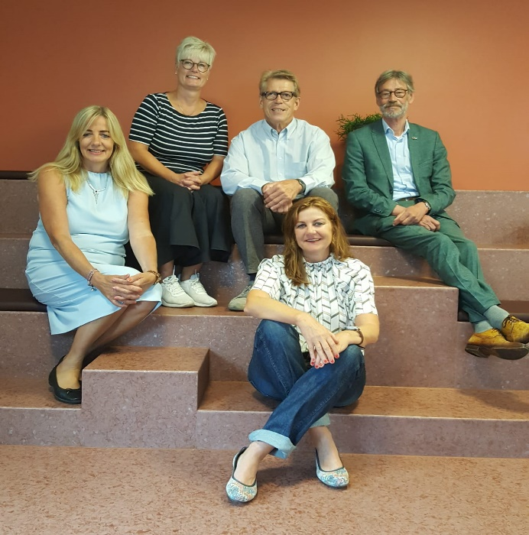

Election of a new President and Vice Presidents will take place at the Board Meeting ahead of the conference.

Magnus Hammar retired as Secretary General in the summer of 2017 following 18 years of service to IUT and its members.

Annika Wahlberg took up the position of Secretary General in August 2017.

Stefan Runfeldt has continued to act as Assistant Secretary to take minutes at Board Meetings and is seconded for 10 per cent of his time from the Swedish Union of Tenants

Barbara Steenbergen has recently celebrated 10 years as head of the IUT Brussels office.

Ilaria D’Auria joined IUT Brussels early in 2019, principally to assist with the ERHIN project.

Stockholm 4 September 2019

Annika Wahlberg
Secretary General
International Union of Tenants

Appendix 7

IUT EU Liaison Office Brussels report of activities 2016-2019

RESPONSIBLE HOUSING INITIATIVE/ EUROPEAN RESPONSIBLE HOUSING AWARDS

Tenant’s empowerment: European Declaration and CSR Code of Conduct
The IUT has always claimed that social housing is not only about providing people with “a roof over their head”, but it should encompass a set of responsible practices in order to effectively achieve the social inclusion of tenants: involvement in decisions, proximity to services and jobs, provision of relevant information and training opportunities, etc. Following this vision, the IUT joined a European partnership working on Corporate Social Responsibility (CSR) consisting of Housing Europe and DELPHIS, a French network of social housing providers: the “European Responsible Housing Initiative” – ERHIN. The European Responsible Housing Initiative is the first and only CSR agreement in the housing sector at European level, supported not only by the two main parties, the social landlords and the tenants, but also a wide range of EU key stakeholders and real estate professionals. It led to the signature of two key documents, the European Declaration and the CSR Code of Conduct». The head of the IUT EU liaison office, Barbara Steenbergen, highlights the political value of the first, which promotes responsible housing policies in EU regions, and the practical value of the second, which has been signed by more than 50 housing associations that implement its principles in their daily work. This CoC includes the assessment criteria for the first European CSR Awards in the housing sector.

European Responsible Housing Awards 2016
After the first edition of the European Responsible Housing Awards at International Tenants Day October 2014 in Brussels, the second edition of the European Responsible Housing Awards 2016 was held in November 2016 at the European Committee of the Regions (CoR) in Brussels, attended by more than 120 participants including housing providers, EU and national authorities, financial institutions, NGOs and universities and opened by CoR-President Karl-Heinz Lambertz: «One of the major problems is the question of investment in relation to the growth and stability pact criteria. A solution could be to exclude social investment in infrastructure from the 3% criteria. The second issue to tackle is the current narrow definition of social housing in the regulations for state aid and SGEI. In order to guarantee a healthy social mix in cities, social housing must be accessible not only to the poorest but also to middle income households». The position of Mr. Lambertz is fully supported by the IUT.

The 2016 winners of the competition: Goedkope Woning from Kortrijk (Belgium); ICF Habitat La Sablière from Paris (France); Shepherds Bush Housing Group from London (UK) and Gewobag Wohnungsbau-AG Berlin (Germany). All finalists’ projects have been published in the ERHIN Handbook 2016.

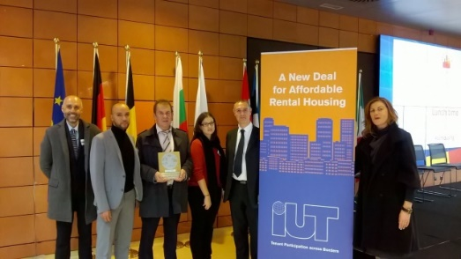
Winning Paris ICF Habitat team with ERHIN-jury chair Barbara Steenbergen (IUT).

A great day for responsible housing: Wiener Wohnen and Est Métropole Habitat Lyon sign ERHIN Code of Conduct
The signing ceremony on 17 October 2018 was hosted by the Austrian Ambassador to Brussels, Mrs. Elisabeth Kornfeind, who herself used to live in one of today’s protected homes in Vienna.

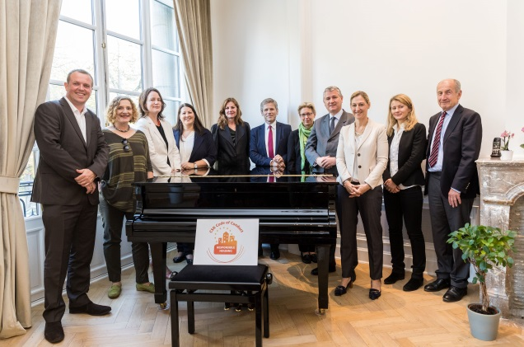
Celebration at the Austrian embassy Brussels, with Ambassador Elisabeth Kornfeind (third right)

Karin Ramser, the director of Wiener Wohnen, and Cédric van Styvendael, director of Est Métropole Habitat Lyon, and President of Housing Europe signed the ERHIN Code of Conduct. Georg Niedermühlbichler, President of the Austrian Union of Tenants, the housing councillor of Vienna, Kathrin Gaál and the Austrian ambassador Elisabeth Kornfeind delivered speeches at the ceremony which took place at the Austrian embassy in Brussels.

Georg Niedermühlbichler, President of the Austrian Union of Tenants MVÖ, with Vienna’s housing councillor Kathrin Gaál.

European Responsible Housing Awards 2019: A firework of best practices
The ceremony of the ERHIN Awards 2019 took place on the 6th of June during the International Social Housing Festival (ISHF).

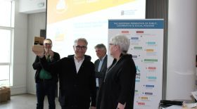
IUT board member Anne Viita (r.) with the winners from Barcelona, represented by housing councillor Josep Montaner (m.)

More than 200 participants from all over Europe, the finalists, European Key stakeholders and representatives from the Region of Grand Lyon attended the ceremony at the University of Lyon to meet the winners of the 5 awards categories and the special prize for innovation which were revealed in this 2019 ERHIN edition. Please find all the finalists in the handbook of the ERHIN Awards.

In 2019, the ERHIN jury received a record-breaking number of 87 submissions from 16 countries and deciding on five winners and finalists was no easy task for the Jury with IUT members from Czech Republic (Lenka Tarabová), Finland (Anne Viita), France, (Eddie Jacquemart), Germany (Heike Zuhse), Norway (Christan Hellevang), the Netherlands (Paulus Jansen), Barbara Steenbergen (IUT Brussels), URBACT, the European Investment Bank, Cooperatives International, the Royal Institution for Chartered Surveyors and Habitat for Humanity, who gathered March 21 at the headquarter of the Swedish and German trade unions in Brussels.

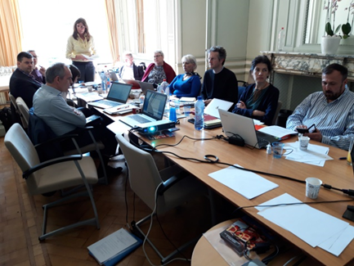
ERHIN Jury members assessing 87 projects

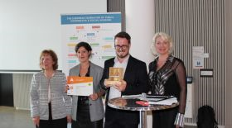
IUT board member Lenka Tarabová (r.) with the winning team of Villeneuve St. Georges

The 2019 winners of the competition Municipal Housing Institute Barcelona (Spain), OPH Villeneuve St. Georges (France), Alwel Breda (The Netherlands), 1892 Genossenschaft Berlin (Germany) and ATC del Piemonte Torino (Italy).

A new edition of the European Responsible Housing Awards is planned for the year 2021.

IMPLEMENTATION OF THE EU'S URBAN AGENDA- THE PARTNERSHIP FOR AFFORDABLE HOUSING 2016-2019

One of the core tasks of the IUT Brussels office, together with the IUT General Housing Policy Working group, was the active contribution to the Action Plan of the EU partnership for affordable housing. Amongst only a few key stakeholders of the European Housing sector, IUT was nominated by the EU member states to work on sustainable, fair and affordable housing solutions for the European housing markets. The Action plan of the EU-partnership is the key document for all necessary concerted actions at EU level (energy Policy, state aid, European semester, EU Pillar of Social Rights, EU funding, anti-speculation policies) as well as the concerted actions at national, regional and local city level.

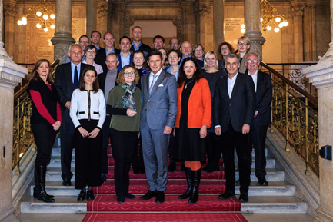
Members of the partnership in the city hall of Vienna, in the centre the coordinators Michaela Kauer and Elena Szolgayová together with Peter Hanke, Executive City Councillor for Finances and European Affairs

The deliveries of the action plan can be clustered in 4 big strands of actions: better regulation, better funding and financing conditions, better knowledge and governance, good housing policies and practices, and themes for future discussion.

Starting in 2016, the objectives of the EU Partnership on Housing were clearly established in the text of the Pact of Amsterdam endorsed by the EU Member States: to have affordable housing of good quality with a focus on public affordable housing, state aid rules and general housing policy. The United Nations, IMF and OECD (UNECE, 2015; Habitat III New Urban Agenda, 2016; OECD 2017, IMF 2011) have clearly pointed to access to affordable housing as a pressing societal issue, in line with the Pact of Amsterdam. The International organisations also clearly state the limited market housing provision along with the mismanagement of the financial aspects of the market housing resulted in the global financial crisis and global housing crisis by extension. There is a need for wide number of affordable housing options provided in tenure balanced manner to counterbalance the results of the global financial crisis- and the goal was to write a comprehensive Action Plan with solutions fitting for Member States, Cities and Regions, financial institutions, housing providers and housing consumers. Focus is public affordable housing, state aid rules and general housing policy. IUT was identified to write the good housing policy and governance part of the action plan and set up an internal IUT general housing policy working group, chaired by Dan Nicander (SUT), in order to write a concerted contribution.

IUT’s main contribution to the action plan
It was a huge amount of work which could only be finalized successfully with an excellent team work of the IUT team members. Our special gratitude goes to: Sven Bergenstråhle, Jan Laurier, Ronald Paping, Anne Viita, Lenka Tarabová, Rolf Gaßmann, Eddie Jacquemart, Lukas Siebenkotten, Annika Wahlberg (IUT board members) as well to Dan Nicander, Johan Mirtorp, Claus Højte, Jutta Hartmann, Reiner Wild, Erik Maassen, Heike Zuhse as members and contributors to the IUT general housing policy working group who drafted the IUT contribution to the EU Action plan. Barbara Steenbergen from IUT EU Office brought the main message to the EU-partnership: “we need regulation to protect the weaker part in the market – unlimited rental contracts and rent caps are core elements here.” IUT president Sven Bergenstråhle contributed with his definition of "affordable housing", also including quality definitions based on the Swedish standard of adequate housing, which. The partnership used as a tool for the revision of the “housing overburden rate” by Eurostat. The Partnership wants to lower this rate from currently 40% to a reference threshold of 25% of disposable income.

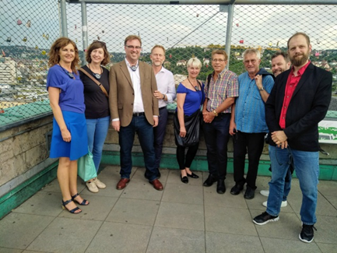
The IUT General Housing Policy Working Group members meeting at DMB in Stuttgart

The IUT position, concentrated on rent regulation and stabilization, security of tenures, anti-speculation policies and affordable rents after energy renovation, has been widely incorporated in chapter III of the action plan, called “Good housing policies” and has been endorsed by all members of the partnership:
Urban Areas: Vienna (AT/Coordinator); Lisbon (PT); Poznan (PL); Riga (LV); Scottish Cities Alliance (UK)
Member States: Slovakia (Coordinator), Latvia, Luxembourg, the Netherlands, Slovenia
Other participants and stakeholders: European Commission (DG REGIO, DG ENER, DG EMPL), AEDES; EUROCITIES; European Investment Bank (EIB); Housing Europe; International Union of Tenants (IUT); URBACT; Union Habitat.
In total, 13 EU partnership meetings were held, hosted by Vienna, Glasgow, UNECE Geneva, Lisbon, Luxemburg, Slovenia and the Netherlands, as well as two complementary workshops on state aid and data in Brussels.
The IUT general housing policy working group met 4 times, hosted by IUT Brussels, DMB (Berlin and Stuttgart) and SON (Prague).
The first recommendations of the partnership have been provided on 20 November 2017 in an interim report by the EU Commission to the Council of the EU. The EU-Commission highlights the following proposals of partnership for housing:
"Services of general economic interest (SGEI)", the target group for the construction of social housing should be expanded to facilitate access to affordable housing for small and medium-sized income groups. The negative impacts of the scheme based on the Dutch case" are evident and need to be revised.

The appropriate in-depth analysis on the impact of the current EU aid regime for affordable housing exists and was the Cabinet of the Vice-President of the EU Commission, Frans Timmermans, on November 29, 2017 by a delegation of the cities Amsterdam, Vienna, Housing Europe, Eurocities and IUT. The partnership calls to improve the legal certainty of the European legislation and to create clarity for more public and private investment in affordable housing.

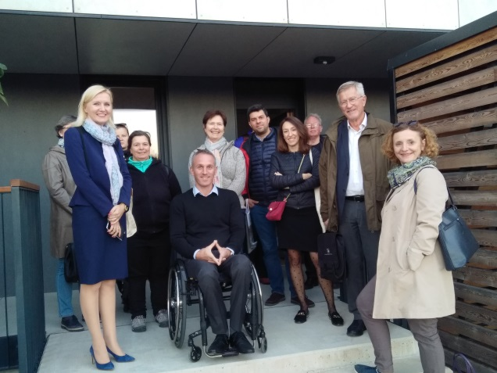
Site visit in Novo Brdo, with housing managers Vesna Dragan and Saso Rink (left and centre), IUT President Sven Bergenstråhle and coordinator Michaela Kauer (r.)

IUT president Sven Bergenstråhle explained his definition of "affordable housing", which the partnership wants to use as a tool for the revision of the “housing overburden rate” by Eurostat. Partnership wants to lower this rate from currently 40% to a reference threshold of 25% of disposable income. The rate is interlinked with the social scoreboard of the European Semester, introduced by the EU pillar of social rights. It is a reference for future EU structural funding for housing and energy efficiency. The partnership also recommends including the eviction rate to the EUROSTAT sources. Barbara Steenbergen (head of IUT EU liaison office) argued for the parts on tenant participation, rent control and energy efficiency in the action plan, which are covered by recommendations on tenant’s participation in the housing associations management plans, prevention of capitalization of subsidies by rent and cost caps and gross-rent neutrality after energetic renovations.

EU-Partnership for affordable housing presents final Action Plan in Vienna, December 2018
Three years of intensive work have come to a successful end- in the spirit of a true multi- level cooperation!
Quoting the coordinators Michaela Kauer and Elena Szolgayová:
“Our results, the Action Plan, lay the foundation to build a comprehensive, evidence-based and sustainable agenda for affordable housing on EU level and they will help cities in securing the right to housing for their populations. The next steps will be to contribute to a sound implementation process, at all levels of governments and in our organizations, and together, in the team spirit we upheld the past three years.”
The Action plan is the most progressive and comprehensive document on housing policy that has ever been published at EU level.

Please find the 100 pages document here: and a brief summary here:
The Action plan has been not only published and sent to the Austrian EU presidency, it also received immense attention at the final conference in Vienna and the international press. Thanks to the hard work of the IUT working group and the IUT board a lot of hands-on recommendations for security of tenure and rent control have been incorporated- this makes us both proud and happy!

Housing for All- IUT presents at International Housing Conference
More than 300 representatives of the EU institutions, politicians from European Member States, cities, housing providers, tenants’ representatives from Austria, Czech Republic, Germany, the Netherlands and Sweden, trade unions and scientists from 36 countries discussed Europe`s housing challenges at the Vienna conference „Housing for all- affordable housing in growing cities in Europe” on the 4 -5 December. The findings of the EU Urban Agenda Housing Partnership were presented to the public audience.

”Housing is a human right – not a commodity” emphasized Leilani Farha, since 2014 the UN Special Rapporteur on adequate housing. At the conference, the Canadian lawyer and activist presented her initiative “Make the Shift”, which is to support municipalities and city administrations in responding rapidly to this negative development. “The speed and extent to which financial enterprises and funds take over housing space and real estate, causing a lack of affordability as well as crowding-out effects and homelessness in the cities, are staggering. Housing is a key issue of the 21st century”.

IUT President Sven Bergenstråhle and Secretary General Annika Wahlberg also contributed to the EU urban agenda brochure “policy guidelines for affordable housing in cities” with a manual “guide to setting up a tenants’ association”.

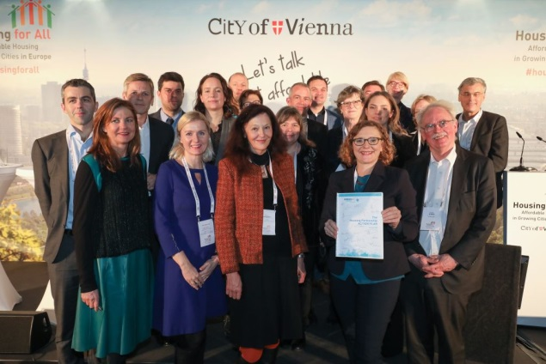
Presenting the first issue of the final Action Plan with all signatories at the Vienna international housing conference

IUT presenting in the EP: affordable housing solutions and Action Plan
The international conference that took place at the European Parliament in Strasbourg on January 17th and 18^{th,} organized by the city of Strasbourg, L’Union Sociale pour l’Habitat and Housing Europe. The conference was attended by key policy makers and stakeholders from across Europe, including the MEPs Karima Delli (Greens/EFA) and Geoffroy Didier (S&D), Cathrine Trautmann, Vice-president of the Eurometropole Strasbourg, Rui Franco, housing councillor of Lisbon, Ulrich von Kirchbach, head of housing department of Freiburg, Kieran McCarthy, councillor of Cork, Michaela Kauer, city of Vienna and Syamak Agha Babaei, housing councillor of the city of Strasbourg. EU- commissioner Corina Cretu delivered a live video intervention. Barbara Steenbergen, head of the IUT EU liaison office, was asked to react on housing policy and examples for affordable housing solutions in the cities of Paris, Bordeaux, London, Stockholm, Berlin, Munich and Warsaw.

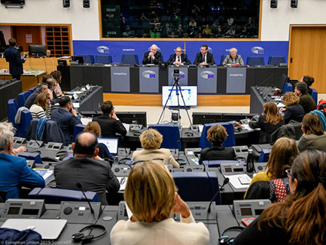
The mayor of Strasbourg Roland Ries opening the session in the European Parliament in Strasbourg

PUBLICATIONS AND PARTNERSHIPS

IUT launches the “Tenants priorities for the new European Parliament 2019 -2024”
In the January 2019, the IUT General Housing Policy Working Group drafted the “Tenants priorities for the new EU parliament, which were endorsed by the IUT board.
IUT’s priorities for the European Parliament 2019-2024 include the following:
- Housing is a fundamental right
- Tenure neutral policies are crucial
- Housing policy is a national competency
- Tenants’ rights as consumers must be protected
- Energy efficiency is an important part of good housing conditions

The IUT priorities for the EU Parliament are an advocacy document for affordable housing and the protection of tenants which can be used as a manifesto for the EU elections as well policy document for the newly elected Members of the European Parliament..

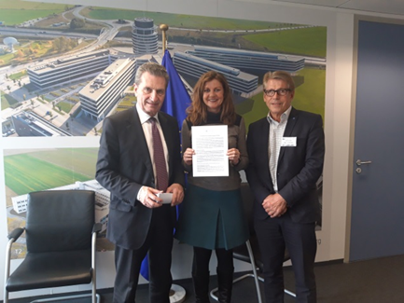
Rolf Gaßmann and Barbara Steenbergen handing over the IUT tenant’s priorities to Günther Oettinger, Vice president of the EU-Commission

IUT contributes to the “Progressive Society” initiative of S&D
From SDGs to real policy: The Independent Commission for Sustainable Equality (ICSE), initiated by the Socialists & Democrats (S&D) Group of the European Parliament, presented in December 2018 its report involving 110 recommendations to fight all forms of inequalities in Europe, in particular social, economic, environmental and territorial. The report is a progressive political program for the next legislative period in the EU, 2019- 2024.

Former Danish Prime minister and member of the EU Parliament Poul Nyrup Rasmussen and Ms. Louka T. Katseli, economist at the University of Athens and former minister for economy and labour of Greece, invited IUT Brussels representative Barbara Steenbergen to contribute to the task force launching the recommendations. The report is published in nine languages, please read the part on housing and rent control from page 111 on.

Strengthening ties with members
In the last three years, IUT Brussels has strengthened ties with its member unions, by working on the classical EU advocacy fields like the EU energy package, European Semester, The European Pillar of Social Rights, state aid to social and public housing associations and strategies against speculation, sale of the public housing stock and “touristification” aggravating cities’ housing shortage by short-term rentals. IUT Executive Committee and board members delivered speeches at the General Assemblies and board meetings of the Deutscher Mieterbund in 2017 and 2019, CNL France 2016 and 2018, Nederlandse Woonbond in 2017 and 2018, MieterInnenverband Switzerland in 2018 and 2019. IUT Brussels’ Barbara Steenbergen also presented at the board meeting of the Swedish Union of Tenants in Brussels, March 2019.

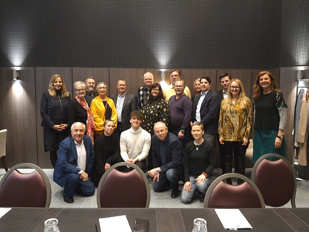
The SUT-board in Brussels with President Marie Linder (2nd left) and IUT’s SG Annika Wahlberg (left)

THE EUROPEAN SEMESTER- THE SOCIAL SCOREBOARD OF THE EUROPEAN PILLAR OF SOCIAL RIGHTS INCLUDED

The IUT board meeting in Brussels, April 2017, was a milestone achieving our goal of implementing changes in the Article 19 of the European Pillar of Social Rights, dealing with housing. In a debate with responsible officials of the Directorate General of the European Commission, Employment and Social affairs (EMPL) and the Vice President of the EU Parliaments’ EMPL committee, Agnes Jongerius MEP, we managed to change the article considerably- from the first versions’ “home ownership” to “social housing or housing assistance” to be promoted by the EU Member States. This is the final wording:
“19. Housing and assistance for the homeless
a. Access to social housing or housing assistance of good quality shall be provided for those in need.
b. Vulnerable people have the right to appropriate assistance and protection against forced eviction.
c. Adequate shelter and services shall be provided to the homeless in order to promote their social inclusion.”

The European Pillar of Social Rights is accompanied by a 'Social Scoreboard' which tracks trends and performances across EU countries in areas related to the principles under the Pillar by tracking trends and performances across EU countries in 12 areas and will feed into the European Semester of economic policy coordination and serves to assess progress towards a social triple A for the EU as a whole.

The European Union has set up a yearly cycle of economic policy coordination, called European Semester. As part of this process, each year the Commission analyses EU member states’ reform programs and provides them with “Country-Specific Recommendations” (CSRs). These recommendations also contribute to the objectives of the EU long term strategy for jobs and growth, so called “Europe 2020 strategy”.

IUT Brussels has been very critical towards the European Semester and the missing implementation of Europe 2020 social objectives. Whereas the Semester, and in particular the CSRs was merely concentrated on economic considerations now the social dimension is linked by the Social Scoreboard- a longstanding claim of IUT and a step in the right direction.

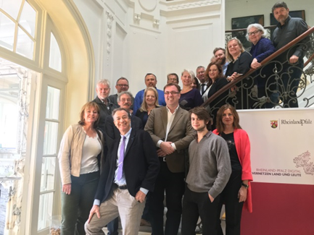

The Brussels board meeting 2017 which was hosted by Pia Wenningmann, head of the representation of Rhineland-Palatinate was also a farewell to IUT secretary general, Magnus Hammar, who left after 18 years in the post (front row in the centre).

@ IUT liaison office to the EU, Brussels

Barbara Steenbergen
Head of the IUT liaison office to the EU
barbara.steenbergen@iut.nu

More information in the bimonthly IUT Brussels newsletters: https://www.iut.nu/eu/iut-brussels-eu-news/

Appendix 8a

Financial Report / Director’s Report 2016-2018

The Board of Directors of International Union of Tenants, (IUT) 802445-3642, may hereby submit the
Annual Report for the financial year 2016-01-01 - 2018-12-31.

Company overview
IUT´s field of activities consist of co-ordination, processing and dissemination of information about tenants´ rights and housing across the world in order to safeguard tenants´ interest and promoting affordable and decent rental housing. Its members consist of 72 national and regional tenants´ organizations in 47 countries. IUT also works, through political lobbying, for the right to decent housing at a reasonable cost and that a sufficient rental housing stock is maintained for social, public and private rental at an affordable rent.

Besides the IUTs head office in Stockholm, with staff and office sponsored by the Swedish Union of Tenants (Hyresgästföreningen), IUT operates an IUT liaison office to the European Union, in Brussels. The staff is sponsored by the German Tenant association (Deutscher Mieterbund e.V.). IUT Brussels carries out its accounting function separately and its figures are not included in this statement of account.

IUT´s activities, publications and operations are funded by membership fees paid by Board Members and Members.

IUT maintains contacts with the European Union, the Council of Europe in Strasbourg and with the United Nations (UN) where IUT holds consultative status with the UN ECOSOC.

The financial result and present financial position, is set out in the attached income statement and statement of financial position

The organization has no staff; thus, no salaries have been paid during the financial year.

The exchange rate used as per 2018-12-31 is 1 EUR = 10,27 SEK.

Disposition of the Result
The financial result for the fiscal years 2016-2018 amounts to € 14 042. The result for each fiscal year has been brought forward to a new account.

Appendix 8b

Income Statement

€ Euro | Note | 2018 | 2017 | 2016
Membership fees |  | 57 444 | 52 721 | 56 119
Grants  Participation fees |  | 0
Other operating income |  | 0 | 496 | 18 891
Operating income |  | 57 444 | 53 217 | 75 010
Operating expenses |  | -38 503 | -48 772 | -84 355
Operating expenses | 1 | -38 503 | -48 772 | -84 355
Operating profit
NET PROFIT |  | 18 942 | 4 445 | -9 345

Appendix 8c

Balance sheet

€ Euro | Note | 2018-12-31 | 2017-12-31 | 2016-12-31
ASSETS
Current assets
Current receivables
Prepaid expenses and accrued income |  | 0 | 353 | 3 833
Cash and bank |  | 132 553 | 121621 | 118 097
Total Current assets |  | 132 553 | 121 974 | 121 930
TOTAL ASSETS |  | 132 553 | 121 974 | 121 930
EQUITY TRANSFERS AND LIABILITIES
Equity | 2
Non-restricted equity
Retained profits |  | 113 508 | 113964 | 125 810
Net profit |  | 18 942 | 4 445 | -9 345
Total equity |  | 132 450 | 118 409 | 116 465
LIABILITIES
Trade creditors |  | 0 | 0 | 736
Accrued expenses and prepaid income |  | 104 | 3 565 | 4 729
TOTAL LIABILITIES |  | 104 | 3 565 | 5 465
TOTAL EQUITY AND LIABILITIES |  | 132 553 | 121 974 | 121 930

Appendix 8d

Note 1 – Operating profit by cost centre

€ Euro |  | 2017 | 2016
Membership, board members |  | 51 160 | 54 506
Membership, other members |  | 1 563 | 1 613
IUT-secretariat Brussels, extra contributions |  | 496 | 0
Interest |  | -2 279 | -3 113
In common |  | -1 809 | -3 253
Member organisations |  | -655 | -605
CEE region (east Europe) |  | -64 | 0
Board meetings and related costs |  | -5 671 | -4 214
UN-ECE/Geneva |  | -1 198 | -1 472
UN Habitat, Nairobi/NY |  | 0 | -732
NGO:s |  | -2 121 | -206
EU related costs, and costs for Brussels office |  | -6 659 | -5 473
Global Tenant |  | -7 150 | -13 405
Translations |  | -303 | -796
IT / Website |  | -16 500 | 0
Marketing |  | 0 | -623
Project funding, members |  | -1 164 | 0
Secretariat |  | -3 201 | -3 117
Congress |  | 0 | -28 455
 |  | 4 445 | -9 345

€ Euro |  |  | 2018
Membership fees |  |  | 57 444
Travel |  |  | -5 794
Lodging |  |  | -2 828
Executive Committee President and VP |  |  | -9 586
Member expenses for Board meetings |  |  | -687
Conferences (Habitat, UNECE, CEO |  |  | 0
IT costs |  |  | -9 754
Publications, printing, typesetting |  |  | 0
Grants |  |  | -640
Auditors |  |  | -1 217
Bank charges |  |  | -106
Office costs |  |  | -974
Brussels office contribution |  |  | -6 907
 |  |  | 18 942

Appendix 8e

Note 2 – Retained profit

€ Euro | Retained profits | Net profit
January 1, 2016 | 121 370 | 10 587
Appropriation of net profit 2015 | 10 587 | -10 587
Appropriation of net profit 2016 | -9 345
Appropriation of net profit 2017 | 4 445
Exchange rate fluctuation (January 1, 2016 – December 31,  2018) | -13 549
Net profit 2018 |  | 18 942
December 31, 2018 | 113 508 | 18 942

Appendix 9

Auditor's report

THIS IS A TRANSLATION FROM THE SWEDISH ORIGINAL

To the general meeting of the International Union of Tenants identity number 802445-3642

Report on the annual accounts
Opinions
We have audited the annual accounts of lnternational Union of Tenants for the year 2018.
In our opinion, the annual accounts have been prepared in accordance with the Annual Accounts Act and present fairly, in all material respects, the financial position of lnternational Union of Tenants as of 31 December 2018 and its financial performance for the year then ended in accordance with the Annual Accounts Act. The statutory administration report is consistent with the other parts of the annual accounts.
We therefore recommend that annual general meeting of the association adopts the income statement and balance sheet.

Basis for Opinions
We conducted our audit in accordance with lnternational Standards on Auditing (ISA) and generally accepted auditing standards in Sweden. Our responsibilities under those standards are further described in the Auditor 's Responsibilities section. We are independent of lnternational Union of Tenants in accordance with professional ethics for accountants in Sweden and have otherwise fulfilled our ethical responsibilities in accordance with these requirements.

We believe that the audit evidence we have obtained is sufficient and appropriate to provide a basis for our opinions.

Responsibilities of the Board of Directors
The Board of Directors is responsible for the preparation of the annual accounts and that they give a fair presentation in accordance with the Annual Accounts Act. The Board of Directors is also responsible for such internal control as they determine is necessary to enable the preparation of annual accounts that are free from material misstatement. whether due to fraud or error.
In preparing the annual accounts, The Board of Directors is responsible for the assessment of the association's ability to continue as a going concern. They disclose, as applicable, matters related to going concern and using the going concern basis of accounting. The going concern basis of accounting is not applied it decision has been taken to discontinue the operations.

Auditor's responsibility
Our objectives are to obtain reasonable assurance about whether the annual accounts as a whole are free from material misstatement, whether due to fraud or error, and to issue an auditor's report that includes our opinions. Reasonable assurance is a high level of assurance, but is not a guarantee that an audit conducted in accordance with ISAs and generally accepted auditing standards in Sweden will always detect a material misstatement when it exists. Misstatements can arise from fraud or error and are considered material it, individually or in the aggregate, they could reasonably be expected to influence the economic decisions of users taken on the basis of these annual accounts.

As part of an audit in accordance with ISAs, We exercise professional judgment and maintain professional scepticism throughout the audit. We also:

ldentify and assess the risks of material misstatement of the annual accounts, whether due to fraud or error, design and perform audit procedures responsive to those risks, and obtain audit evidence that is sufficient and appropriate to provide a basis for our opinions. The risk of not detecting a material misstatement resulting from fraud is higher than for one resulting from error, as fraud may involve collusion, forgery, intentional omissions, misrepresentations, or the override of internal control.
Obtain an understanding of the association’s internal control relevant to our audit in order to design audit procedures that are appropriate in the circumstances, but not for the purpose of expressing an opinion on the effectiveness of the association's internal control.
Evaluate the appropriateness of accounting policies used and the reasonableness of accounting estimates and related disclosures made by the Board of Directors.
Conclude on the appropriateness of the Board of Directors' use of the going concern basis of accounting in preparing the annual accounts.
We also draw a conclusion, based on the audit evidence obtained, as to whether any material uncertainty exists related to events or conditions that may cast significant doubt on the association's ability to continue as a going concern. If we conclude that a material uncertainty exists, we are required to draw attention in our auditor's report to the related disclosures in the annual accounts or, it such disclosures are inadequate, to modify our opinion about the annual accounts. Our conclusions are based on the audit evidence obtained up to the date of our auditor's report. However, future events or conditions may cause the association to cease to continue as a going concern.
Evaluate the overall presentation, structure and content of the annual accounts, including the disclosures, and whether the annual accounts represent the underlying transactions and events in a manner that achieves fair presentation.

We must inform the Board of Directors of, of among other matters, the planned scope and timing of the audit. We must also inform of significant audit findings during our audit, including any significant deficiencies in internal control that we identified.

Auditor's report for a limited liability association without group

Report on other legal and regulatory requirements

Opinions
In addition to our audit of the annual accounts, we have also audited the administration of the Board of Directors of lnternational Union of Tenants for the year the financial year 2018.
We recommend that annual general meeting of the association that the members of the Board of Directors be discharged from liability for the financial year.

Basis for Opinions
We conducted the audit in accordance with generally accepted auditing standards in Sweden. Our responsibilities under those standards are further described in the Auditor's Responsibilities section. We are independent of the association in accordance with professional ethics for accountants in Sweden and have otherwise fulfilled our ethical responsibilities in accordance with these requirements.
We believe that the audit evidence we have obtained is sufficient and appropriate lo provide a basis for our opinions.

Responsibilities of the Board of Directors
The Board of Directors is responsible for the association's administration.

Auditor's responsibility
Our objective concerning the audit of the administration, and thereby our opinion about discharge from liability, is to obtain audit evidence to assess with a reasonable degree of assurance whether any member of the Board of Directors in any material respect has undertaken any action or been guilty of any omission which can give rise to liability to the association.
Reasonable assurance is a high level of assurance but is not a guarantee that an audit conducted in accordance with generally accepted auditing standards in Sweden will always detect actions or omissions that can give rise to liability lo the association.
As part of an audit in accordance with generally accepted auditing standards in Sweden, we exercise professional judgment and maintain professional scepticism throughout the audit. The examination of the administration is based primarily on the audit of the accounts. Additional audit procedures performed are based on our professional judgment with starting point in risk and materiality. This means that we locus the examination on such actions, areas and relationships that are material for the operations and where deviations and violations would have particular importance for the association's situation. We examine and test decisions undertaken, support for decisions, actions taken and other circumstances that are relevant to our opinion concerning discharge from liability.

Stockholm, 14 May 2019 Ernst & Young AB

The Board proposes the Congress:

  - to approve of the financial report,
  - to approve the auditors’ report,
  - to discharge the IUT Secretariat from liability.

Appendix 10

Appointment of auditors for 2020 – 2022

Proposal:
The Board has approved the suggestion to accept Ernst & Young Ltd, or other auditor chosen by the Swedish Union of Tenants, and two representatives of the Swedish Union of Tenants as auditors for 2020 - 2022.

Appendix 11

Approval of membership applications 2016-2019

The IUT Board has, at board meetings during 2016-2019 approved as members the organisations above who have confirmed that they will comply with the IUT Statutes for membership.

Categories: M=Member (paying €60,00/year), AM = Associated Member (no fee)

Democratic Republic of the Congo (Congo-Kinshasa)
Association Pour la Protection et Droit des Locataires au Congo (APDLC), "Association for the Protection and Rights of Tenants in Congo” is confirmed as a Member of IUT (M).

Burundi
Association de Défense des Locataires au Burundi (ADELOB), Organisation for the Tenants’ Rights Defence in Burundi, is confirmed as an Associate Member of IUT (AM).

Brussels
Rassemblement Bruxellois pour le Droit à l'Habitat/Brusselse Bond voor het Recht op Wonen, “Brussels Association for the Right to Housing” is confirmed as a Member of IUT (M).

Toronto
The Federation of Metro Tenants' Associations (FMTA) is confirmed as a Member of IUT (M).

Appendix 12

Cessation of Membership

No organisation has officially discontinued their membership of IUT

Appendix 13

IUT Activity plan 2019-2022

EXECUTIVE SUMMARY:

OVERALL OBJECTIVES

- Increase awareness and membership of IUT and assist in strengthening tenants’ organisations
- Engage with other stakeholders to leverage our work for the betterment of Tenants’ rights and conditions and industry engagement
- Work with researchers and academics to distribute analysis and research

ADVOCACY AND HOUSING POLICY

What | How
Housing is a fundamental right | Promoting Article 34 of the Charter of Fundamental rights of the EU, where everyone have the right to a decent existence, like social and housing assistance. Use arguments for labour mobility.
Housing as a social right, with requires affordable housing | Promoting everyone’s right to affordable and decent housing, where rent negotiations and other negotiations needs to prevent skyrocketing rents or increased rent after luxury renovation is prevented. Advocate against market rents and “renovictions” as well as promote tenure neutrality in respect of tax systems.
Promote good housing policies | Campaigning work against the housing speculation from private investors, which have created a push-effect of both working class and middle class from central, attractive residential areas. Enhance inclusive and sustainable urbanization and capacity for participatory, integrated and sustainable human settlement planning and management in all countries.
Promote tenants’ empowerment and educate about structured tenant participation and tenants’ rights as consumers | Support universal access to safe, inclusive and accessible, green and public spaces, in particular for women and children, older persons and persons with disabilities. Support positive economic, social and environmental links between urban, peri-urban and rural areas by strengthening national and regional development planning combined with the participation of tenants.
Ensure urban planning and management practices to deal with the challenges brought by urbanization | Promoting the UN sustainable development goals, particularly goal 11, with affordable housing, sustainable transport system and basic services. Advocate against the sale of the public and social housing stock. Advocate for affordable energy efficiency.
Change existing state-aid rules | Do not limit access to social and affordable housing solely to socially disadvantaged groups. Lobby for subsidiarity. Communicate ways of achieving desired results within existing regulations.
Work against the financialization of housing | Follow the Shift initiative by the UN rapporteur for Housing. Promote Push the film. Advocate against misuse of short-term rental platforms to avoid depletion of housing stock at the expense of cities.
Work for housing policy all over the world whilst also taking the issues of migration and climate migration | Support least developed countries, including through financial and technical assistance, in building sustainable and resilient buildings utilizing local materials. Support the adopting and implementing of integrated policies and plans towards inclusion, resource efficiency, mitigation and adaptation to climate change, resilience to disasters, and develop and implement.

Action – not just words
All our advocacy and housing Policy work should be done through campaigning, promoting and supporting the development of knowledge and information exchange, through exchange of best practice and through issuing position papers.

REPORTING
a. Regulations
What is on the regulatory horizon
Continue to look at and where possible influence the development of regulations affecting IUT members in liaison with these members and monitor the development of housing policies that may affect tenants.

Method
Gauge early effects of key regulations that are under implementation
Follow the debate around housing politics and regulation

b. Market development and news
Monitor market and political developments and their impact on IUT members

Method
Regular regulatory and market updates and market related roundtables and seminars if relevant together with Newsletters, and website articles.

PARTICIPATION IN NETWORKS

Continue active participation in housing networks and committees, follow activities of organisations whose goals are in opposition to IUTs objectives.

National roll-out of action plans from networks in which IUT participates
Who: national associations with the help of IUT.

ACTIVITIES
- Respond to consultations in EU which has a bearing on IUT members, In co-operation with members
- Respond to consultations by EU, UN, COE and other relevant international organisations
- Monitor developments in relevant fields including early planning for legislative or regulatory or interpretative changes, keeping national tenant membership organisation informed appropriately, i.e. through early warnings.
- Provide commentary to IUT member organisation on relevant matters both to keep them informed and to permit feedback from members.
- Promote the exchange of knowledge and ideas on Tenants associations and its activities, e.g. Membership benefits and best practice
- Working Groups
- Solidarity activities

NEWS AND COMMUNICATION
- Website
- Newsletter
- EU newsletter
- Press releases
- Introducer to press opportunities by Board members but also other members of IUT.

EVENTS
- Board Meetings
- European Responsible Housing Initiative
- Organise ERHIN awards 2021
- Highlight Tenants’ role in the world
- International Tenants day annually
- International Consumers’ day annually
- Promote campaigns in relations to Tenants’ rights E.g. Citizens’ initiative for affordable housing
- Organise briefings by specialists
- Participate in conferences, roundtables and seminars

MEMBERSHIP
- Expand membership
Geographic expansion of IUT (non-EU Europe, Africa, South America, potentially in cooperation with others)
- Review membership fees
- Member meetings
Continue to strengthen ties and exchange with members
- Explore Regional committees
- Assist in study visits by members and bilateral exchanges

FINANCES and ADMINISTRATION
- Prudent budgeting
- Investigate funding opportunities
- Governance structure review
- Resources review

Appendix 14

IUT EU liaison office Brussels Activity plan 2019-2022
Solidarity, exchange of knowledge, advocating and policy

The EU and housing: The Urban Agenda

Since January 2008 IUT runs a liaison office to the EU in Brussels. IUT’s lobby work in Brussels has made IUT a respected actor in the EU capital. Although housing as such is not an EU competence, but up to the EU member states, regions and cities to decide and create laws on, a number of EU topics have great influence on national housing policies, such as state aid regulations for social housing, EU funding for social and affordable housing and urban renewal, The EU urban agenda, the EU stability and growth pact, the EU semester, and energy and climate policy.

IUT serves as expert in the relevant committees and working groups of the EU institutions and is formal member of the EU Urban Agenda Housing Partnership, a high level stakeholder group set up in 2016-2019 by the EU commission and the EU member states to revise EU legislation for better funding, better knowledge and capacity building in the field of affordable and social housing. The EU Urban Agenda Housing Partnership presented their Plan of Action in December 2018. Now is the time for the national roll-out. We will need the support of the IUT member unions to get spread the action plan, which is so far the most progressive document on affordable housing, produced in a multi-level governance between EU Commission, EU-Member States, cities and key stakeholders like social landlords and tenant organisations.

Housing is a fundamental right

As approximately a third of the EU citizens live in rented dwellings, tenancy law affects the daily lives of large numbers of citizens. To provide a level playing field for tenants, it is crucial that the EU supports work at Member State level related to security of tenure and affordable rents.

According to Article 34 of the Charter of Fundamental rights of the EU, the Union recognizes and respects the right to social and housing assistance to ensure a decent existence for people who lack enough resources. This obligation is limited not only to rules laid down by the European Union institutions but applies also to national law and practices.

Everyone should have the right to affordable and decent housing.

The European Union and integration have brought the people of Europe freedom, democracy and the longest period of peace in history. When migratory movements are not accompanied by the provision of affordable housing, they aggravate the housing shortage in European metropolitan areas. Nationalist movements use this development to incite against immigrants and to fight against the achievements of European Union and integration. Promoting the provision of affordable housing is therefore not only a social policy imperative, but a measure to combat xenophobia and nationalism.

IUT’s vision of Europe is one where all citizens have a home that they can afford easily. Housing constitutes a fundament for all to participate in our society. Secure, affordable and healthy housing is a precondition to access education, employment and genuine social security. The social and affordable housing sector contributes actively to the Europe 2020 goals as it has the capacity to create growth and jobs, thus contributes to sustainable local economies, combats poverty and social exclusion and delivers and important part to work against climate change and energy poverty. EU legislation affecting housing policies thus has direct effects on the lives of European households. Housing is one of the key questions of sustainable well-being for all. Therefore, the IUT advocates for better housing policies in a more social Europe.

For 2019–2022 IUT Brussels, together with the member unions, plans to continue its activities in raising awareness on the increasing housing costs for tenants, which have negative aspects on the entire economy. “Ensure affordability and counteract housing speculation” will be the central message towards EU decision makers. Increasing public financing from EU funds and a favourable legislative framework for affordable housing will contribute to the provision of more affordable and social housing, investment in deprived communities and urban renewal. Tenant’s empowerment, structured tenant participation in decision making about their living environment is the key to create inclusive and strong neighbourhoods.

Stop the selling out of our cities

Counteract housing speculation will contribute to more housing affordability- IUT needs to advocate against the sale of the public and social housing stock, the massive concentration on European housing markets, the financialization of housing, and tax evasion and money laundering in the real estate sector.

The touristification of cities by the massive expansion of short time lettings is aggravating the European housing crisis. It is important to work together with the cities to enforce measures and strategies at city and supranational level. Misuse of international short-term rental platforms for purely commercial purposes jeopardizes tenant rights in touristic regions and cities. Urban planning and applicable legislation should be respected in the sharing economy to avoid the depletion of city centres at the expense of residents.

Housing and state aid- de-block investment in affordable housing by changing the existing state aid rules

As the state aid package is one of the most important legal frameworks of the EU, we expect a long and hard political negotiation process which we can only influence with the strong support of the national tenant unions and concerted actions at EU and national level.

The currently applicable EU State aid rules, by enforcing the single market rules on the housing sector, force Member States to limit access to social and affordable housing solely to socially disadvantaged groups while the needs of other groups in need have been largely neglected. Such application of legislation denies the fact that housing alternatives are not readily available for low and middle-income groups due to possible market failures in the housing sector.

Consequently, defining the mission and the role of social and affordable housing is a task that must remain under the exclusive competence of the EU Member States, including the setting of criteria for allocation of social and affordable housing to people in need.

When struggling with segregation, ghettoization and the promotion of social cohesion and urban mix, a wide diversity of social and affordable housing ought to be dictated by local and regional needs. Social and affordable housing should be accessible to large parts of the population, not only to a limited target group. Consequently, the rules relating to Services of General Economic Interest (SGEI), in particular recital 11 of the EU commission’s decision need to be adapted accordingly. Subsidiarity should be strictly enforced.

Tenants’ rights as consumers must be protected

Housing needs are one of the most basic human needs. The rights of the tenants as consumers in the housing market need to be in the focus of good housing policy, as they are the weaker party. Consequently, tenants should not be subject to a weaker protection than consumers of other goods and services are offered. As housing is such a crucial need, tenants therefore should not be denied the same rights to demand agreements drafted in transparent, plain and intelligible language as any other consumer agreement. Tenants should also have a right to request that contractual terms are brought to their attention in such a way that the average and well-informed consumer could understand them. Tenants should in line with this have the right to challenge terms which are: unfair, written in small print, or written in unintelligible language. The EU should actively support and promote consumers’ rights to fair treatment on the housing market, as well as influence on their housing conditions including their neighbourhoods.

Tenants are consumers on the housing market and should enjoy strong protection in relation to their consumer rights. – IUT members will work in solidarity to strengthen tenant’s position and resist deterioration of tenant’s terms.

Affordable energy efficiency is an important part of good housing conditions

The cost of energy represents a substantial part of living costs to many households. At the same time energy consumption should be reduced. In 2018, the new EU clean energy package was decided. The Commission stated that the EU does not only want to adapt the global clean energy transition, but to lead this transition. We need energy-efficiency and renewable energy to stop the climate change, to raise European security of supply and reduce the need for importing gas. Solving these issues would contribute to a better climate quality as well as provide the Europeans with healthier and more affordable homes. Costs and burdens related to renovations of residential dwellings should be distributed in an equitable manner to counteract differences between social groups.

Currently, the big challenge is to allow equal access to energy-efficient housing not only to those that can afford it but also to those who cannot. As the EU promotes energy efficiency measures, consideration must also be given to that housing conditions and energy systems differ greatly between the EU Member States and the details are best worked out in each Member State.
Part of the new clean energy directives is also the training of tenants and residents in energy saving measures. IUT encourages member unions to participate in the relevant hearings, workshops and meetings with the EU institutions. Energy-efficient housing concerns us all. Though subsidiarity should be strictly enforced, EU funding should be available where needed.

EU stability and growth pact, European Semester, Country Specific Recommendations and the EU pillar of social rights: Tenure neutral policies are crucial
In the yearly cycle of economic policy coordination, called “European Semester”, the EU analyses EU member states reform programs and provides them with country specific recommendations. These recommendations contribute to the EU long term strategy for jobs and growth, the “Europe 2020 strategy”. In the last years, progressive social housing policies and rent regulation mechanisms in a growing number of member states have been in the focus of the EU commission, claiming e.g. for downsizing the social housing sector in the Netherlands and deregulation of the rental market in Sweden. IUT Brussels will, in cooperation with the member unions in the affected states, continue to claim for an incorporation of the social objectives of the EU pillar for social rights in the European semester. The European Pillar of Social Rights is intended as a key response to the aftermath of the financial crisis and as an update of the European social model in the light of a changing labour market. The Pillar is meant to stimulate the reduction of poverty and social exclusion through adequate social protection, and to support labour market access and well-functioning welfare systems. In article 19, the pillar foresees the access to social housing or housing assistance of good quality for those in need. This claim should be mirrored in the EU semester assessment of member states housing policy.
But- member States have withdrawn their support to social and affordable rental housing resulting in large segments of the society being neglected. Instead focus has been on promoting home ownership by all means. Instead of promoting a model based on ownership, a tenure neutral position expressed through public policy, financial requirements, and fair tax incentives could achieve wide availability of suitable housing alternatives irrespective of income, age, or gender of tenants. The goal of housing policy should be housing for all – not home ownership for all.

In addition, the investment in social infrastructure like social and affordable housing should not fall under the 3% deficit threshold (Maastricht criteria) of the EU stability pact. This view is supported by the EU Urban agenda partnership for affordable housing

EU funding for housing

The share of the European Regional Development Fund (ERDF) dedicated to energy efficiency and renewable energy as well as sustainable urban development increased to at least 20% in the current programming period, 2014-2020. This is an excellent opportunity to reduce the costs for housing and energy by using public EU funding.
The European Investment Bank (EIB), partner of the EU Urban Agenda Housing Partnership as well as Jury member of the European Responsible Housing Awards, is a key player when it comes to the financing of housing and states its willingness to increase the support by new financial instruments like revolving funds at member states, regions and larger cities level, fed by EU funds like the European structural investment funds (ESIF) and the European fund for strategic infrastructure (EFSI) and the follow up funds from 2021- 2027, Invest EU.
The EU institutions acknowledge the key role of housing construction for an economic recovery in Europe. IUT follows this new development precisely in order to influence it in the right way, for more affordable and social rental housing. IUT will continue to monitor future EU funding possibilities very closely.

European Responsible Housing Initiative

IUT is chair of the Jury of the European Responsible Housing Awards, the common initiative with Housing Europe and Delphi’s to promote Corporate Social Responsibility (CSR) and tenant’ s empowerment in the housing sector.
The European Responsible Housing Awards, firstly issued at International Tenants Day 2014, and in a second edition 2016 at the Committee of the Regions (CoR) in Brussels, is based on the Code of Conduct of the European Responsible Housing Initiative.
IUT members of the jury are Confederation Nationale du Logement, Deutscher Mieterbund SON, Vuokralaiset and Nederlandse Woonbond. The European Responsible Housing Awards 2019 is held in Lyon, June 6.

EU Parliament elections May 2019

IUT has published the Tenants´ priorities for the EU legislation period 2019-2024, and will continue the regular dialogue with the Members of the European Parliament and with the members of the Committee of the Regions (CoR) and the European Social and Economic Committee (EESC). IUT will encourage MEPs to continue the Urban Intergroup, dealing with urban and housing issues.

Major events

International Tenant´s Day October 2020 and 2021, European Responsible Housing Awards 2021

Internal Affairs

Information on relevant EU policies and IUT actions by the bimonthly EU Brussels newsletter
Strengthening ties and exchange with members
Continue the exchange of knowledge, good practices, opinions and advocacy strategies in the IUT general housing policy working group and follow international trends in housing policy to keep members well informed
Establish closer cooperation with housing researchers and scientific institutions
Continue working in strategic European partnerships

IUT Memberships/Partnerships in Brussels

- Member of the EU Urban Agenda Housing Partnership
- Member of the European Economic and Social Committee (EESC) liaison group
- Member of the European Housing Forum, EHF
- Member of the Social Platform
- Member of the Progressive Society Initiative
- Partner of the Intergroup Urban of the European Parliament
- Partner of the Intergroup on Public Services of the European Parliament
- Member of the EU Commissions’ vulnerable consumer working group (DG SANTE)
- Member of the EU Commissions’ group on sustainable construction (DG Enterprise)
- Member of the EU Commissions’ Energy Efficiency stakeholder group (DG Energy)
- Member of the social domain working group of the European Federation for Living (EFL)
- Member of the EU working group of the federal German ministry for housing
- Member of the urban renewal and housing working group of the German Länder representations in Brussels
- Member of the Committee for construction of the German construction industry
- Member of the working group for European Integration of the Friedrich-Ebert-Foundation
- Member of the Etterbeek circle (various EU based civil society and stakeholder organization.

Appendix 15

International tenants’ day 7th October 2019

This year the International Tenants’ Day, celebrated on the first Monday of October each year, coincides with the United Nations Special rapporteur’s launch in 2019 of “The Shift” http://www.unhousingrapp.org/the-shift and ” Push the film”. https://www.youtube.com/watch?v=k9Q4So4femM

The International Union of Tenants (IUT) has therefore chosen these themes together with the United Nations Sustainable Development Goals, https://www.un.org/sustainabledevelopment/sustainable-development-goals/ in particular goal number 11, Make cities inclusive, safe, resilient and sustainable https://www.un.org/sustainabledevelopment/cities/: as the recommended themes when Tenants celebrate the International Tenants’ Day around the world.

The IUT supports its members in making their own choice at a national or regional level as to which sub-themes they may want to promote.

About IUT: The International Union of Tenants (IUT) was founded in 1926 and is a non-governmental and not-for-profit umbrella membership organisation with the purpose of safeguarding tenants’ interests and promoting affordable and decent rental housing across the world. Its members consist of 72 national and local tenants’ associations in 46 countries. IUT offices are located in Stockholm and in Brussels. IUT considers housing as one of the fundamental rights, which needs to be addressed locally, nationally and internationally. Adequate housing is also one of the safeguards for peace and security.

Stockholm, September 2019

http://www.responsiblehousing.eu/en/Responsible-Housing/European-Declaration-on-Responsible-Housing/
http://www.responsiblehousing.eu/en/Responsible-Housing-CSR-Code-of-Conduct/Code-of-Conduct/
http://ec.europa.eu/economy_finance/economic_governance/sgp/index_en.htm
https://www.youtube.com/watch?v=Pduf9tUkVIw
https://www.youtube.com/watch?v=J7wfy0Ce5jo
https://www.youtube.com/watch?v=n3_9yrGrsd8
https://www.youtube.com/watch?v=n3_9yrGrsd8
https://www.iut.nu/wp-content/uploads/2018/08/EUROPEAN-RESPONSIBLE-HOUSING-AWARDS-HANDBOOK-2016.pdf
https://www.wien.gv.at/presse/2018/10/18/wachsende-staedte-eine-europaeische-herausforderung
https://www.iut.nu/news-events/erhin-awards-winners/
https://www.iut.nu/news-events/european-responsible-housing-awards-handbook-now-published/
https://www.youtube.com/playlist?list=PLiSlXg3Q3z_bM6jWaK88eMRBOZfF-u3b6
https://ec.europa.eu/futurium/en/system/files/ged/pact-of-amsterdam_en.pdf
https://ec.europa.eu/futurium/sites/futurium/files/housing_partnership_-_guidance_paper_on_eu_regulation_and_public_support_for_housing_03-2017.pdf
The final Action Plan: https://ec.europa.eu/futurium/en/system/files/ged/final_action_plan_euua_housing_partnership_december_2018_1.pdf Press text of the final Meeting of the Housing Partnership Vienna - Action Plan 1 - https://ec.europa.eu/futurium/en/housing/presentation-action-plan-and-discussion-follow-final-meeting-housing-partnership-vienna Press release on Action Plan 2 of the Housing Partnership -https://ec.europa.eu/futurium/en/housing/empowering-cities-invest-affordable-housing Press release on Action Plan 3 of the Housing Partnership - https://ec.europa.eu/futurium/en/housing/better-knowledge-base-and-exchange-good-policy-and-practice-housing
https://ec.europa.eu/futurium/en/system/files/ged/background20paper20euua20housing20partnership2012-2018.pdf
https://www.flickr.com/photos/154411916@N08/sets/72157674210737687/with/31246164427/
https://www.youtube.com/watch?v=k9Q4So4femM
https://www.strasbourg.eu/web/strasbourg.eu/-/-le-logement-abordable-un-defi-pour-les-villes-et-les-metropoles-europeennes- https://ec.europa.eu/futurium/en/housing/actions
https://www.facebook.com/notes/iut-international-union-of-tenants/iut-priorities-for-the-european-parliament-2019-2024/2565723850121464/
https://www.progressivesociety.eu/publication/report-independent-commission-sustainable-equality-2019-2024

